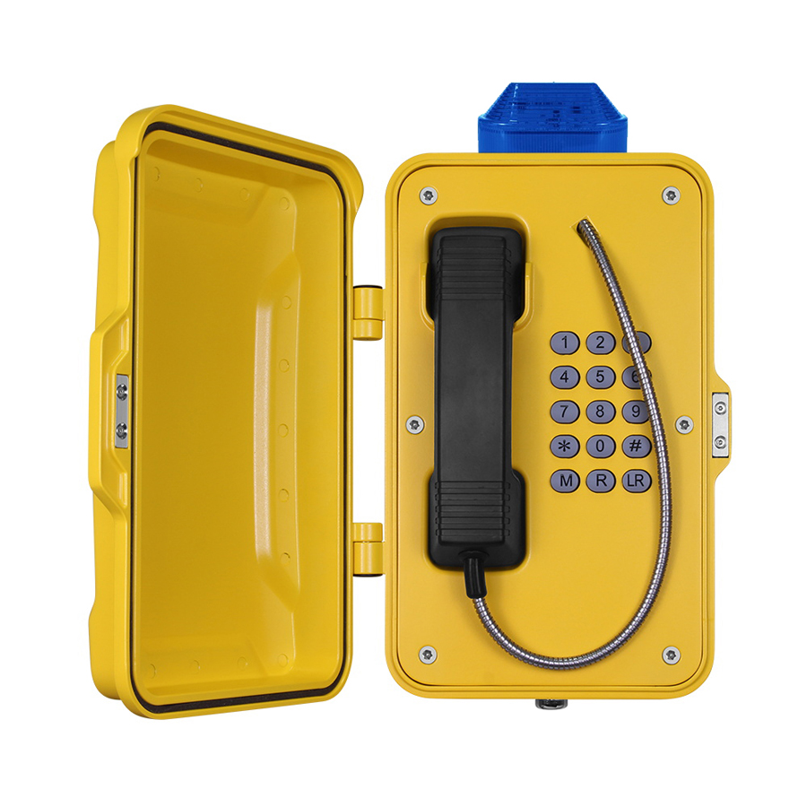 | - Standard Analogue phone or SIP phone  - Aluminum alloy die-casting body  - Vandal resistant handset and cord  - Weather proof protection to IP67  - Full keypad, with LED lamp  - Wall mounting, simple installation  - Inductive coupler fitted as standard for hard of hearing  - Phone line powered/AC/DC powered  - External power supply or PoE (SIP)  - RJ45 Port for SIP connection  - With LED lamp fixed on the top  - CE,FCC,ROSH compliant
The JR100 series telephones are fully contained within a corrosion resistant cast aluminium weatherproof case with a door providing complete protection against dust and moisture ingress, resulting in a highly reliable product with a long MTBF.  The unique robust handset is manufactured from moulded Bulk Molding Compound and designed specifically to withstand arduous use in all environments, armoured cord to provide additional resistance to vandalism or heavy industrial use.  The JR100 series Weatherproof Telephones are designed for use by the railways, power stations, the armed services and heavy industry which require very reliable telephony under adverse conditions.  Standard Analogue  As a standard analogue telephone, this unit provides basic telephone functions and can be connected to any standard two-wire telephone line, including analogue PABX lines and PSTN.
  SIP-VoIP TECHNICAL SPECIFICATIONS
  Power Input:
  12-24V DC
  Port:
  WAN: 10/100Base- T RJ-45 for LAN, Auto MDIX
  LAN: 10/100Base- T RJ-45 for PC, Auto MDIX
  Power Consumption:
  Idle:1.5W/ Active:1.8W
  Voice Features
  - Support SIP 2.0 (RFC3261)
  - Codec: G.711A/u, G.7231 high/low, G.729, G.722
  - Echo cancellation: Support G.168 and hand-free can support 96ms
  - Supports full duplex
  - SIP support SIP domain, SIP authentication(none, basic,MD5),DNS name of server
  - DTMF:SIP info, DTMF Relay，RFC2833
  - Call control features: Flexible dial map, support hot-line
  Network Features
  - WAN/LAN: support Bridge mode
  - Support static IP address
  - Support DHCP get IP on WAN port
  - Support VLAN
  - Support web config

TECHNICAL SPECIFICATION  Casing Material  Die cast aluminium, epoxy powder coated. Colors  Gray, other colors to special order  Handset Material  Cycoloy with stainless steel spiral cord  Keypad  Weather resistant full Keypad  Temperature  Operating: -30°C to +65°C  Storing: -40°C to +75°C  Weather Resistance  IP67  Ringing Tone  Shrill warble tone 85 dBA @ 1 metre typical  Hook switch  Electronic / magnetic with no visible moving parts  M.T.B.F.  Calculated to have an M.T.B.F. in excess of 50,000 hours using  Weight  Up to 7 kg depending on option  ANALOGUE Dialing  MF (tone)  Power supply  Drawn from telephone line  Lightning / Transients  Protection to ITU-T k.21 enhanced levels  Programming  Can be programmed as an auto-dial phone by build-in keypad or remote programming | DIMENSIONS:  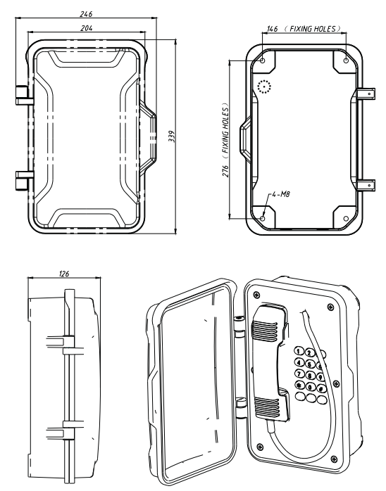  (Measured in mm)  APPROVALS  This mark indicates compliance with the:  Radio & Telecommunications Terminal Equipment Directive  2004/108/EC    This mark indicates compliance with the:  FCC Part 15 Subpart B Class B  PACKAGE  unit size: 339 *146 *126(mm)  Carton size:200*300*440( mm )  Packaging materials: pearl cotton, carton  Gross weight: 7KG Net weight: 6KG

